**Medical Laboratory System Database Project Report**

1. **Project Overview**

The Medical Laboratory System (MLS) database is designed to efficiently manage all operational aspects of a medical laboratory. This comprehensive system tracks patient information, laboratory staff, medical tests, testing components, and test results while supporting essential business queries and reporting functions.

|  |  |  |
| --- | --- | --- |
| Table | columns | PK/FK |
| Laboratorian | LaboratorianID, Name, Phone, Address | PK: LaboratorianID |
| Patient | PatientID, Name, Phone, Address, BirthDate, Job | PK: PatientID |
| component | ComponentID, Name, AvailableQuantity, MinimumQuantity | PK: ComponentID |
| MedicalTest | TestID, Name, Price | PK: TestID |
| TestResult | TestID, Date, PatientID, LaboratorianID, Result | PK: (TestID, Date) FK: TestID, PatientID, LaboratorianID |

1. **Conceptual list (Attributes&Entities):**
   1. **Entities & Attributes Analysis**

The database organizes information into six Attributes:

* **Laboratorian**

- Role: Performs medical tests and records results.

***- Attributes:***

- LabID (Primary Key): Unique identifier for each lab technician.

- Name: Full name of the laboratorian.

- PhoneNumber: Contact information.

- Address: Residential or work address.

* **Patient**

- Role: Individual undergoing medical tests.

***- Attributes:***

- PatientID (Primary Key): Unique identifier.

- Name: Full name.

- PhoneNumber: Contact details.

- Address: Home address.

- BirthDate: For age-related medical assessments.

- Job: Occupation (may influence test requirements).

* **Component (Lab Materials):**

- Role: Reagents, chemicals, and materials used in tests.

***- Attributes:***

- ComponentID (Primary Key): Unique identifier.

- Name: Description of the component (e.g., "Glucose Reagent").

- AvailableQty: Current stock level.

- MinimumQty: Threshold triggering restocking alerts.

* **Medical Test**:

- Role: Defines different types of tests offered.

***- Attributes:***

- TestID (Primary Key): Unique identifier.

- Name: Test name (e.g., "Complete Blood Count (CBC)").

- Price: Cost of the test.

* **Test Result:**

- Role: Records the outcome of a test.

- ***Attributes:***

- ResultID (Primary Key): Auto-incremented unique identifier.

- TestID (Foreign Key): Links to the MedicalTest table.

- PatientID (Foreign Key): Links to the Patient table.

- LabID (Foreign Key): Identifies the laboratorian who conducted the test.

- Date: When the test was performed.

- Result: Detailed outcome (e.g., numerical values, observations).

**4. ER Diagram description**

1. Laboratorian-Performs-TestResult ***(One-to-Many)***:

- One laboratorian can perform multiple test results.

2. Patient-Has-TestResult ***(One-to-Many)***:

- A patient can have multiple test results.

3. MedicalTest-Uses-Component ***(Many-to-Many):***

- A test may require multiple components, and a component may be used in multiple tests.

**4.1.Cardinality & Participation Constraints:**

Total Participation:

Every TestResult must link to one Patient, one Laboratorian, and one MedicalTest.

Partial Participation:

- Components may not be associated with any test.

**5. DDL & DML**

**5.1.DDL (SQL Script)**

**5.2.DML (Sample Queries)**

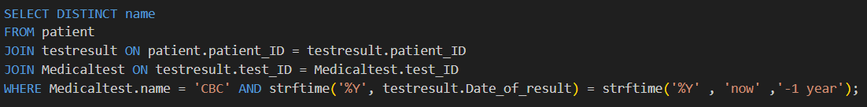

**6. Test Data**

Sample Rows

* **Laboratorian Table:**

|

* **Patient table**

**7.** **Conclusion**

* This Medical Laboratory System Database is designed to:
* Improve efficiency in test tracking and reporting.
* Ensure data accuracy with strict relational integrity.
* Support decision-making* through advanced queries.